GSAP-DataPro Product data

Version: 1
Status: Initial Draft
Prepared By: Girish S. Pai
Last Updated On: Sep 15, 2008

Document Information

Deliverable Name | Functional Specification GSAP_to_DataPro_ProductData.doc
Author | Girish S. Pai
Owner | Christine Blanchet
Team
Source Application Owner | Bruno Duchamp
Source Application technical contact | Sameer Dusane (SD), Ramachandra D N (MM)
Target Application Owner
Target Application technical contact | Vincent Godet
Status | Initial Draft
Version

Document Review & Sign-off

Signatories
Role | Name | Signature | Date
Source Application Owner
Source Application technical contact
Target Application Owner
Target Application technical contact

Reviewers
Role | Name | Comments Received | Date
Source Application technical contact
Target Application technical contact

Revision History

Version No. | Date | Author | Revision Description
0.0 | 15/09/08 | Girish S. Pai | Initial Draft
0.1 | 25/09/08 | Rosie Sasidharan | Updated Message Mapping Sheets embedded
0.2 | 02/10/08 | Rosie Sasidharan | Updated Material Master Message Mapping Sheet
0.3 | 07/10/08 | Rosie Sasidharan | Added 1 extra field for Pricing mapping sheet and corrected non production SYNRJ Database user name
0.4 | 07/10/08 | Rosie Sasidharan | Updated occurrence details for Mapping Sheets
0.5 | 06/04/09 | Rajesh Shanmugasundaram | Mapping sheet updated as per charm 8000006896
0.6 | 05/03/10 | Saju A | Mapping Sheet updated as per chaRM 8000011103

Other Related Documents

Related Document | Comment

Table of Contents

1. Sign-off Checklist 5
2. Introduction 6
2.1. Executive Summary 6
2.2. Purpose of this document 6
2.3. Document Structure 6
3. Overview and Scope 7
3.1. Interface Requirement Back ground 7
3.2. Functional Description 7
3.3. Dependencies / Constraints 7
3.4. Assumptions 8
3.5. Document Scope 8
4. Business Process Overview 9
4.1. Current Scenario 9
4.2. To-Be Scenario 9
5. Functional Requirements 10
5.1. Functional Specification 10
5.2. Interface Process Flow Diagram 10
5.3. Security Requirements 10
6. Interface Requirements 11
6.1. System Details and Direction 11
6.2. Transaction Volume 11
6.3. Frequency and Timing 11
6.4. Initiating Process / Transaction / Program 12
6.5. Processing Type 12
6.6. Proposed Transfer Method / Program 12
6.7. Target / Source Data Layout 12
6.8. Mapping SAP fields to Source / Target 12
6.9. Network Integration 12
6.10. Reporting and Monitoring 12
6.11. Error Handling 12
7. SAP Requirements (if applicable) 13
7.1. Selection Screen Details 13
7.2. Transaction Screen Sequence (if no load module exists) 13
7.3. Post Interface Activities 13
7.4. Legacy System Extract/Load Procedure 13
7.5. Security and Authorization 13
7.6. Reconciliation Procedures and Audit Requirements 13
7.6.1. Approach 13
7.6.2. Metrics 13
7.7. Batch Requirements 13
7.8. Data Maintenance Requirements 13
8. Process and Operational Considerations 14
8.1. Performance 14
8.2. Processing Type 14
8.3. Backup and Archiving 14
8.4. Change Management Requirements 14
8.5. Migration Requirements 14
8.6. Reprocessing and double loading requirements 14
8.7. Other 14
9. Testing Requirements 15
9.1. Key Business Test Conditions 15
10. Design Alternatives 16
11. Outstanding Issues 17
12. Appendix 18
12.1. Glossary of Terms 18
12.2. Additional Supporting/Reference Documentation 18

Sign-off Checklist

Use the following checklist to guide your completion of the Functional Design Document.

Standards and Consistency
Has the correct template been used and all sections been completed as required?
Are the correct details (Business Owner for sign-off, status etc) displayed on the front page?
Have all the assumptions been documented properly so that there are no open issues in the document?
Has the document history been continuously updated?

Integration and Dependencies
Have all inputs and outputs been identified and confirmed?
Have all referenced documents been listed (other business process designs, sub process designs, spreadsheets, information papers, etc.)?

Design
Has the report development technique been identified
Has an example of existing RICEF object been included?
If the report is of type modification (custom development), has it been approved?
Have all areas of impact been identified?

Performance
Have the performance implications, metrics and targets been documented?
Has the performance and volume usage of the report development been considered?

Exceptions and Error Handling
Have the exceptions and likely errors been defined and listed?
Does the document describe what steps (if any) need to be taken after an exception has been raised?
Have all the applicable business scenarios been considered, along with the corresponding test conditions?

Usability – From the user perspective
Has the report attempted to maximize the efficiency of the user (i.e. simple to use, intuitive, quick to use)?
Are any manual steps clearly defined and carefully designed?

Flexibility – From a business perspective
Have all steps been clearly identified and documented so new functionality can be added in the future?

Additional information
Has security been considered (e.g. authority checking considered, target group of users who should be given access to the report etc)?
Are the test conditions sufficiently detailed to enable a full test of all required functionality?

Introduction

Executive Summary

Purpose of this document

This document is used to describe the functional design of the interface GSAP-DataPro Product Data. It aims to give an understanding why the interface is needed and detailed information about the functional requirements.

Document Structure

The document is divided into the following sections:
<Provide a list of the sections here, and add a one line description of the contents>

Overview and Scope

Interface Requirement Back ground

GSAP – DataPro Product Data
Short description
Business Area: | CROP |  | Date:
Business Module | SD and MM * |  | Category | PR and MaterialMaster
Requested by: | Chiristine Blanchite |  | Tel no:
New scenario | Yes No
Priority: | High/mandatory Medium/recommended Low/optional
Business Impact  Results if no solution is created: |  | Legal requirements not fulfilled  Lack of essential business information  Lack of functions compared to legacy system  Others:
Is there an alternative in the standard system / Contingency ? |  | Yes No
Description of alternative:
Reasons why alternative is not acceptable: |  | Performance problems Complexity  Others:

*Here there are 4 messages and below is the distribution into Business Module and Category for each of them

Message Type | Business Module | Category
Pricing Conditions | SD | PR
Material Master | MM | Material Master
Safety Data | MM | Material Master
Classification Data | MM | Material Master

Functional Description
DataPro is a new application being developed at France, which will be used to publish the material data on Syngenta web site for all the materials that are sold in France. This information is used by Sales, Marketing and Distributors of Syngenta. For this reason the materials information maintained in GSAP needs to be sent to DataPro application. The information that is required is Material Master, Classification Data, Safety Data and the Pricing Conditions.

Dependencies / Constraints

- IDoc configuration would be required with GSAP system
- IDocs are triggered through daily batch jobs in SAP.

Assumptions
None

Document Scope

Scope of this document is to define Functional requirement for GSAP-DataPro Integration which involves building of interfaces for 4 Messages listed as below:
- Material Master
- Classification Data
- Safety Data
- Pricing Conditions

The document will define the proposed interface flow for these messages; it provides the details of field structures involved at source and destination systems and the mapping between source and destination structure. It also provides details of end systems involved.

Business Process Overview

Current Scenario
DataPro is a new application being developed and hence there is no integration currently available between GSAP and DataPro

To-Be Scenario

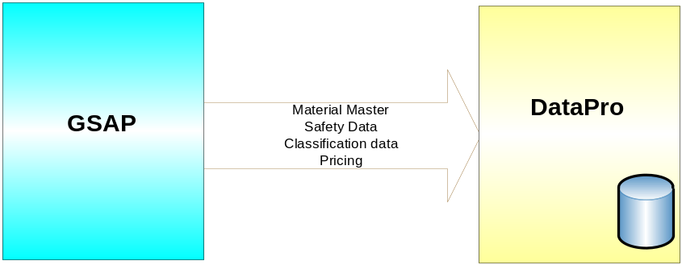

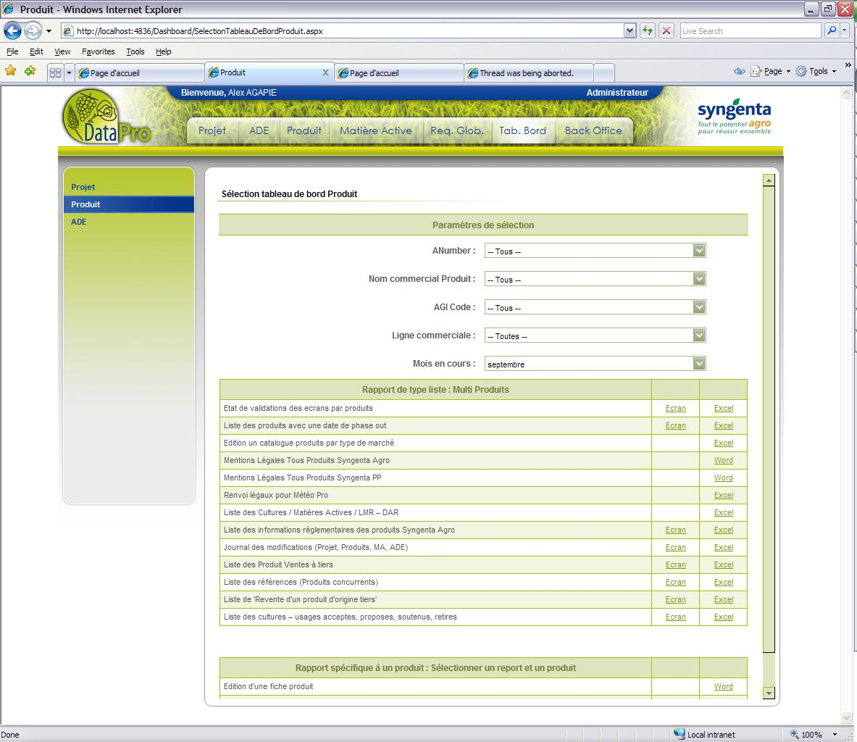

- In the new scenario, Data from GSAP will be sent in the form IDocs on a daily basis for all the 4 different messages.
- OASIS PI will load these data in DataPro Tables. Once the data is updated in main tables users will be able to view it on the web application.

Functional Requirements

Functional Specification

- The z-program at SAP which runs as a batch job, fetches the data from SAP tables, populates the IDocs and sends it to OASIS PI/XI. This program basically sends the data only when there are changes in SAP tables.

- 4 different IDocs are received from SAP below 4 messages:
    - Pricing and Conditions
    - Material Master
    - Classification Data
    - Safety Data

- The data received through these IDocs will be uploaded into respective temporary tables in DataPro by means of stored procedures.

- The data stored in temporary tables are picked up and distributed to various other main tables by the job running at DataPro server. Once the main tables are updated in the DataPro database, it will be visible on the web application.

Interface Process Flow Diagram

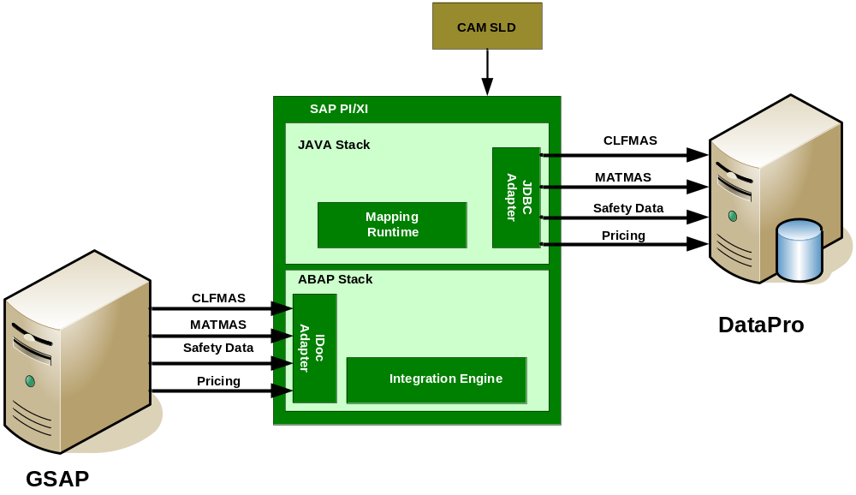

Security Requirements
None.

Interface Requirements

System Details and Direction

Receiving System: DataPro

 | Development | Integration | UAT | Staging | Production
Host Name | FRSCSQL2K04 | FRSCSQL2K04 | FRSCSQL2K04 | FRSCSQL2K04 | FRSCSQL2K03
Database Name | BD_SYNRK | BD_SYNRK | BD_SYNRK | BD_SYNRK | BD_SYNRK
Port | 1433 | 1433 | 1433 | 1433 | 1433
User Name | OASIS_test | OASIS_test | OASIS_test | OASIS_test | OASIS
Type | SQL 2000 | SQL 2000 | SQL 2000 | SQL 2000 | SQL 2000
Location / Site | France | France | France | France | France
System Role | Message Dest

Sending System: GSAP

 | Development | Integration | UAT | Staging | Production
System ID | E1B | I1B | U1B | Q1B | P1B
Client | 010 | 010 | 010 | 010 | 010
Appserver (Hostname) | sape1b.eame.syngenta.org | sapi1b.cp.chbs | sapu1b.cp.chbs | sapq1b.cp.chbs | sapp1b.cp.chbs
System Number | 06 | 02 | 00 | 01 | 00
Gateway | sapgw01 | sapgw02 | sapgw00 | sapgw01 | sapgw00
Location / Site | Basel | Basel | Basel | Basel | Basel
User
Password
System Role | Message Source

Direction: Outbound to GSAP for all the 4 messages

Transaction Volume

Material Master –
Classification Data –
Safety Data –
Pricing Conditions –

Frequency and Timing

This is a daily interface and the batch job at SAP would run every day at 20:00 CET

Initiating Process / Transaction / Program

Each of the interface flows are triggered by the IDocs sent from SAP. These IDocs are created by the z_program xxxxxx which is run as batch job running everyday.

Processing Type

Processing of the IDocs received from SAP and upload into DataPro Database is real-time.

Proposed Transfer Method / Program
At the source end the data is received in the form of IDocs. At the destination end the data is uploaded into the Database tables using stored procedures.

Target / Source Data Layout

Safety Data –

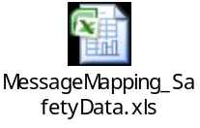

Pricing –

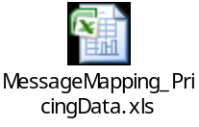

Material Master –

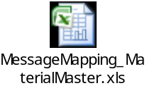

Classification Data –

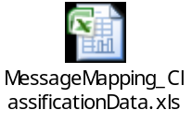

Mapping SAP fields to Source / Target
Please see section 6.7

Network Integration
None

Reporting and Monitoring
None

Error Handling
- Failure of IDocs due to connection issue
- Failure of IDocs due to data issue?
- Stored procedure failure due to connection issue
- Stored procedure failure due to data issue?

SAP Requirements (if applicable)

Selection Screen Details
Not applicable.

Transaction Screen Sequence (if no load module exists)

Post Interface Activities
The stored procedures executed by the interfaces, upload the data into temporary tables and the Database jobs would then run at xxxx time to update the main tables.

Legacy System Extract/Load Procedure
None

Security and Authorization
OASIS PI system would require authorization to execute the stored procedures on DataPro database. The credentials provided in section 6.1 will be used for this.

Reconciliation Procedures and Audit Requirements

Approach
Not Applicable

Metrics
Not Applicable

Batch Requirements
No batch requirements from OASIS PI interface side.

Data Maintenance Requirements
None

Process and Operational Considerations

Performance
No special performance considerations as data volume is not huge and no time bound data upload requirements into DB.

Processing Type
There is a batch job at SAP which trigger the IDocs to PI. However in PI, processing of these IDocs and upload into DataPro will be real-time.

Backup and Archiving

No special requirements for back-up/archiving. Even the successful messages need to be archived for at least 3 months by default.

Change Management Requirements

None

Migration Requirements

After the go-live, to synchronize the data between GSAP and DataPro initial load for all the 4 messages needs to be run. The initial load volume for each of these messages is expected to be:

Material Master –
Classification Data –
Safety Data –
Pricing Conditions –

Reprocessing and double loading requirements

There is no impact of double loading as the job at DataPro, which picks up the data uploaded by the interface, looks for distinct records.

Other

Testing Requirements

Key Business Test Conditions

ID | Condition | Expected results | Cycle Ref.

Design Alternatives
Background
Options
Recommendation and Decision

Outstanding Issues

Issue No | Description | Assigned To | Status | Impact | Resolution

Appendix

Glossary of Terms

Term | Definition

Additional Supporting/Reference Documentation

